**Evidence template - Conduct an inquiry 91890**

**Menu (jump to sections):**

1. Identify your focus area and develop inquiry questions
2. Establish milestones and manage your time
3. Undertake research to gather information
4. Organise and analyse information
5. Propose a digital technologies outcome to meet the identified opportunity or need
6. Summarise the results of the inquiry

# Part 1: Decide on an inquiry focus and develop inquiry questions

|  |
| --- |
| **What is my theme?**  My theme is: |

|  |
| --- |
| **Using focus questions to explore my theme**  What aspects of the theme are relevant to me, my friends and family and/or my community?  Who does it involve? What does it look like? Where is it?  What causes it? Why does it happen? How does it happen?  What can be done about it? What is being/has been done? What could I do?  How can I link this to a digital outcome? |

|  |
| --- |
| **Choosing my key issue**  Here are some of the issues within my theme:  1.  2.  3.  I have decided to focus my inquiry project on the issue of: |

|  |
| --- |
| **My inquiry question:** |

# Part 2: Establish milestones

|  |
| --- |
| **What project management tool/s will I use?**  I plan to use ………………………… to organise my time during my inquiry project.  I chose this/these because: |

|  |
| --- |
| **Set up my chosen project management tool**  If I am using an online project management tool, the link to it is: …………………….. |

|  |
| --- |
| **Identify my tasks**  Here is a list of the steps I will need to take throughout this inquiry project. (It might help to skim ahead through the resource to see what is coming up) |

|  |
| --- |
| **Add milestones at important points in my inquiry timeline**  My milestones are at these points in my inquiry process:  (This evidence may be a screen-shot or a list. It should show dates and key tasks or points in the project) |

|  |
| --- |
| **Image of my chosen project management tool**  Insert a screen-shot or photo of the initial setup of my chosen project management tool, showing my tasks and milestones. |

# Part 3: Undertake research to gather information

|  |
| --- |
| **What I want to know:**  What is the problem or issue I’m trying to solve?  What are my initial ideas about what outcome I might propose? (*This idea may change as a result of your research - don’t get too attached to it!*)  A reminder: My main inquiry question is/are:  Some other questions I want answers to as part of my inquiry are:  (I may add to this list as I learn more through my research) |

|  |
| --- |
| **What implications could my outcome have?**  **Implication** ………………………………………  Explaining the implication  How might this be relevant to my outcome?  What research might help me address this implication in my outcome?  **Implication** ………………………………………  Explaining the implication  How might this be relevant to my outcome?  What research might help me address this implication in my outcome?  **Implication** ………………………………………  Explaining the implication  How might this be relevant to my outcome?  What research might help me address this implication in my outcome? |

|  |  |  |  |
| --- | --- | --- | --- |
| **Source** | **What I asked or was looking for** | **What I found out** | **How I can use this information** |
|  |  |  |  |
|  |  |  |  |
|  |  |  |  |
|  |  |  |  |
|  |  |  |  |
|  |  |  |  |
|  |  |  |  |
|  |  |  | *(insert rows as needed)* |

# Part 4: Organise and analyse information

|  |
| --- |
| **Analysing my findings**  *(Not all of these will be relevant to my project)*  The results of my research in an organised way such as in a mind-map, graphic organiser or diagram:  Graphs to display and compare data:  Discussion about the findings of my research in relation to the **inquiry question(s):**  Discussion about the impact of the findings of my research on my ideas for the **proposed outcome:**  Analysing different **perspectives** on my issue:    Analysis of any relevant **implications** I discovered that relate to my issue and outcome |

# Part 5: Propose an outcome

|  |
| --- |
| **Step 1: Thinking about possible outcomes**  What do I want to accomplish? Why?    Who are my target audience?  Some potential outcomes that I could make that would meet this purpose are: |

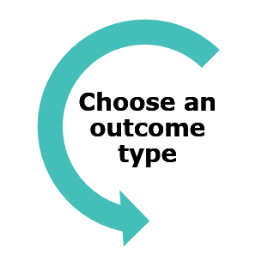

|  |
| --- |
| **Step 2: Choose an outcome type**  What type of outcome am I going to propose?  Why? *(refer to my research if possible)*  Requirements of the outcome *(rough first draft)*: |

|  |
| --- |
| **Step 3: Refining outcome plans**  What will be the benefits of my proposed outcome?  Who else might have an interest in my proposed outcome?  What resources will be required in the making of my proposed outcome?  How/where will users interact with my proposed outcome?  What is the intended reach of my outcome? (eg. students at my school, people in my town, NZ or global?)  What problems might I face?  What implications are relevant to my issue and outcome, and how will I cater for these?  What requirements does my proposed outcome need to meet in order to work well? |

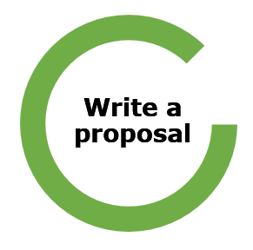

|  |
| --- |
| **Step 4: Write a proposal**  **Concept** - What is the outcome, what will it do?  **End users** - Who will use or benefit from my outcome?  **Requirements** - What requirements will the outcome need to meet in order to be effective?  **Resources** - What resources will be required to make the outcome? |

|  |
| --- |
| **Improve my proposal** (optional)  I got feedback on my proposal from and I improved it by |

# Part 6: Summarise results

|  |
| --- |
| **Summarising my results and drawing insightful conclusions**  How my research findings helped me answer my inquiry questions:  How my research findings led to my choice of final outcome:  Decisions that I needed to make, and how I used my research to help me decide:  Implications are relevant to my outcome, and how my proposed outcome meets these. *(Refer to my research findings if possible)*  Describe stakeholder perspectives on your issue and your proposed solution. (Be sure to mention any opposing or surprising perspectives):  How my proposed outcome provides a solution to my issue:  *(Make sure I explain how it meets the needs or opportunities arising from:*   * *the inquiry question* * *stakeholder perspectives)*   **Conclusion:**  I might mention:   * What I have learned that I didn’t know before this investigation * Any wider impacts that my outcome might have * Any of my assumptions were challenged by what I discovered during this inquiry * How I can measure the success of my proposed outcome |